**Assignment 1.2**

**Problem Statement**

Explain the below Linux commands with an example. Share the screen shot of each

command with the output:

1. **pwd** :‘pwd‘ stands for ‘Print Working Directory‘. As the name states, command ‘pwd‘ prints the current working directory or simply the directory user is, at present.

Syntax :

pwd [OPTION]

Example :

type –a pwd

Print all the locations containing executable named pwd

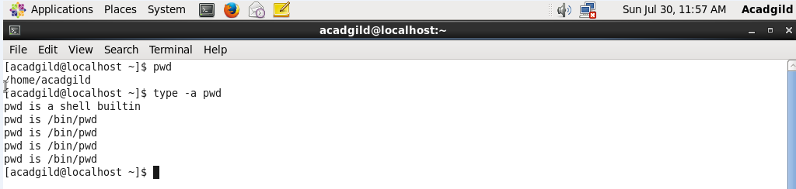

2. **vi** :vi is a visual text editor.You can use the vi editor to edit an existing file or to create a new file from scratch. You can also use this editor to just read a text file.

Syntax :

vi [option]

Example :

vi filename

Creates a new file if it already does not exist, otherwise opens an existing file.

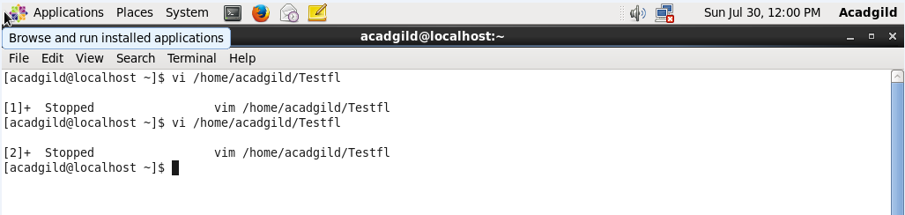

1. **touch** :  The touch command is a standard program for Unix/Linux operating systems, that is used to create, change and modify time stamps of a file.

Syntax :

touch [option] file_name(s)

Example :

Touch Divya

The above touch command creates an empty (zero byte) new file called Divya.

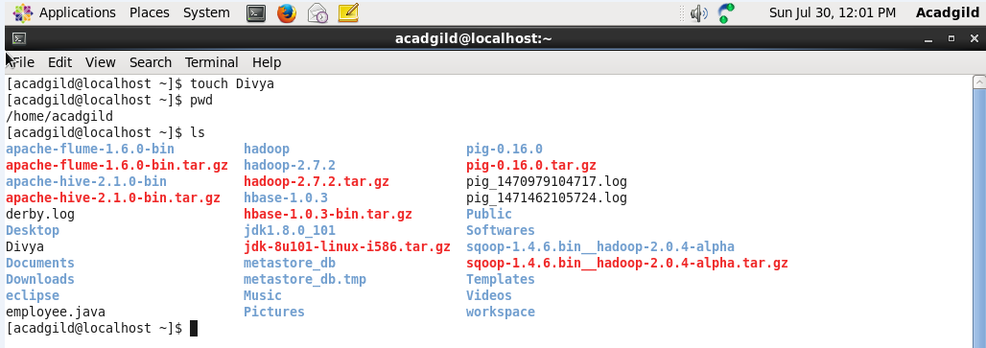

1. **mkdir** : mkdir is used to create [directories](https://www.computerhope.com/jargon/d/director.htm) on a [file system](https://www.computerhope.com/jargon/f/filesyst.htm).

Syntax :

mkdir [option] directory.

Example :

mkdir mydir

The above command Creates a new directory called mydir whose parent is the current directory.

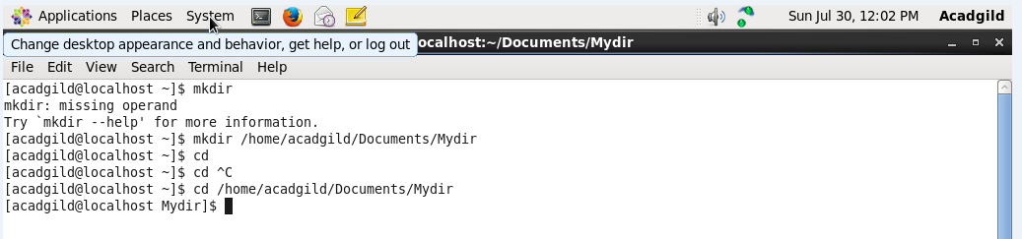

5.**rm** :The rm command removes ([deletes](https://www.computerhope.com/jargon/d/delete.htm)) [files](https://www.computerhope.com/jargon/f/file.htm) or [directories](https://www.computerhope.com/jargon/d/director.htm).

Syntax :

rm [option] file

Example :

rm myfile.txt

The above command Remove the file myfile.txt. If the file is write-protected, you will be prompted to confirm that you really want to delete it.

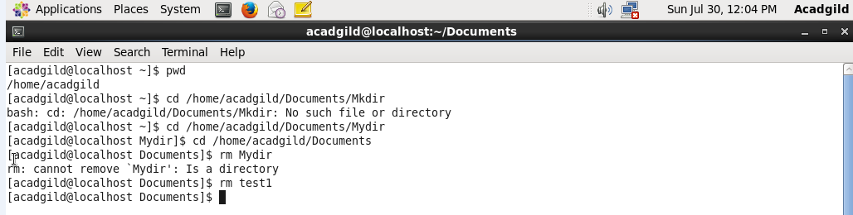

1. **ls** :ls with no option list files and directories in bare format where we won’t be able to view details like file types, size, modified date and time, permission and links etc.

Syntax :

ls[option]

Example :

ls -l

 ls -l shows file or directory, size, modified date and time, file or folder name and owner of file and it’s permission.

Executed commands till ls.

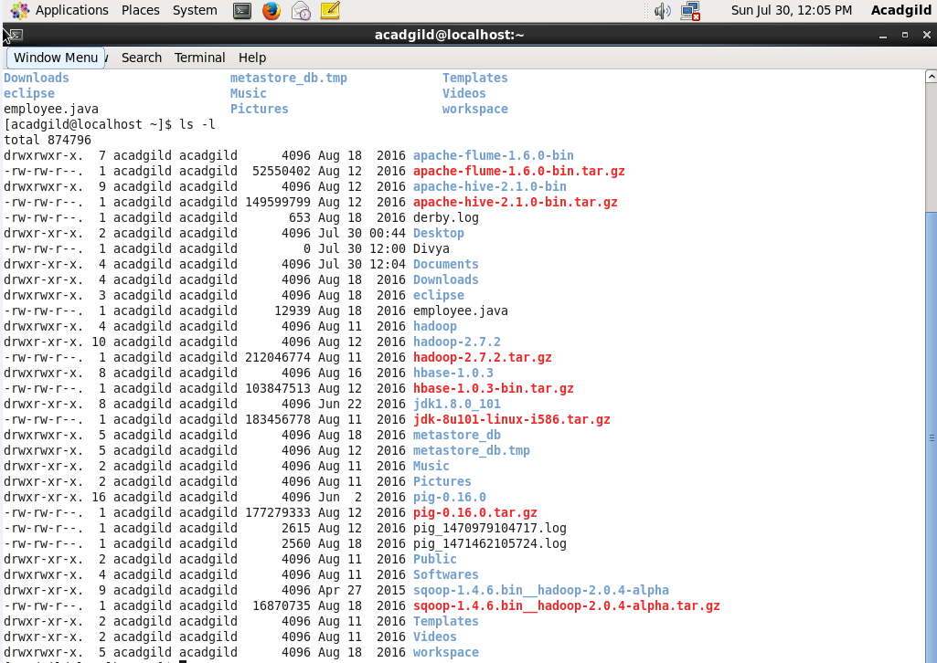

1. **echo** :echo displays a line of text.

Syntax :

echo[option]string..

Example :

echo hello world!.

Outputs hello world!.

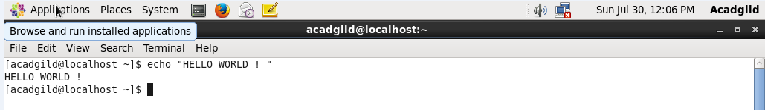

1. **cat** :cat command allows us to create single or multiple files, view contain of file, concatenate files and redirect output in terminal or files.

Syntax :

cat [option]

Example :

Cat filename

Outputs the content of filename.

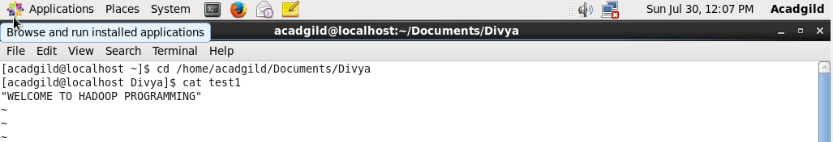

1. **who** : Displays who is logged on to the system.

Syntax :

who[option][file ][am I].

Example :

Who am i

Displays the username, line, and time of all currently logged-in sessions.



1. **cd** : The cd command, which stands for "change directory", changes the shell’s current working directory.

Syntax :

cd[option].

Example :

cd .

The current directory, regardless of which directory it is, is represented by a single dot (".").

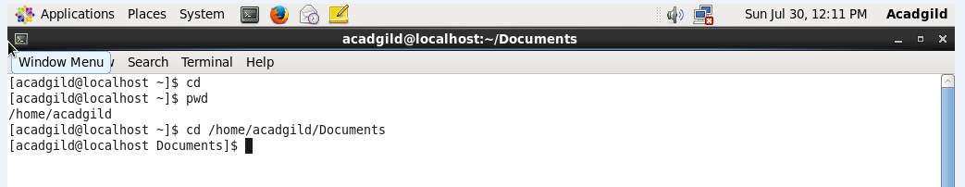

1. **date** : The date command is used to print out, or change the value of, the system's time and date information.

Syntax :

Date[option][format]

Example :

date

Running date with no options will output the system date and time.

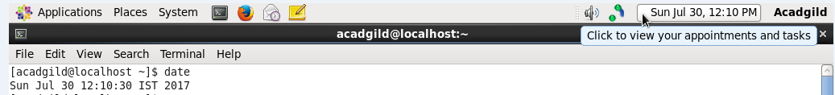

1. **cal** :Display a conveniently-formatted calendar from the command line.

Syntax :

cal[option][[[day]month]year]

Example :

Cal

Displays the calendar for this month.

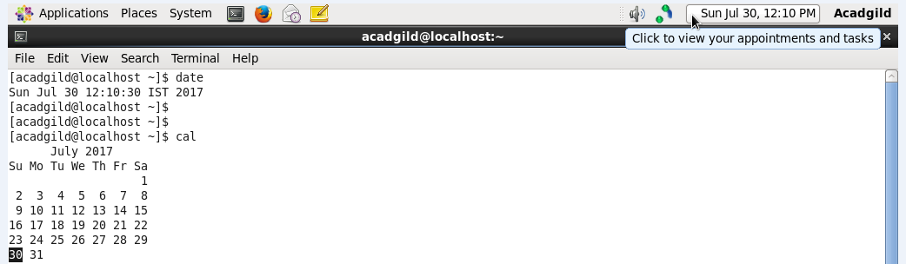

1. **mv** : The mv command is used to move or rename files.

Syntax :

mv[option]Source..Directory

Example :

mv file.txt destination-dir.

Moves the file file.txt to the directory destination-directory.

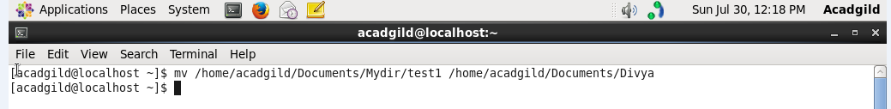

1. **cp** :The cp command is used to make copies of files and directories.

Syntax :

cp[option]Source..Directory

Example :

cp origfile newfile

Creates a copy of the file in the working directory named origfile. The copy will be named newfile, and will be located in the working directory.

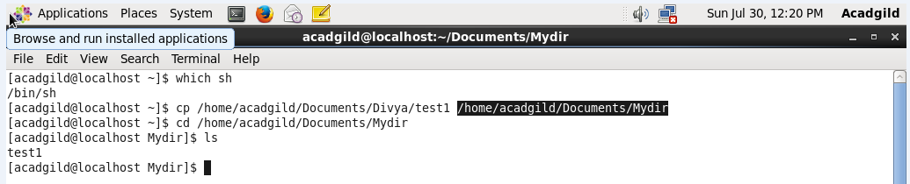

1. **which** : Locate the executable file associated with a given command.

Syntax :

Which -a[filename]

Example :

Which sh

Locates the pathname of the file which would be run if the sh command were executed.

